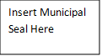

[Municipality]

2024 Climate Vulnerability Assessment
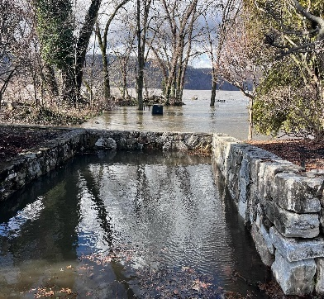
SWAP in picture of municipality
[MONTH, YEAR]
Produced by the [Municipality] Climate Smart Communities Task Force
with Assistance from the Hudson Valley Regional Council and
ICLEI – Local Governments for Sustainability USA

Adopted on [Date]

CAPI Adapt is a project of the Hudson Valley Regional Council. This document was prepared for the Hudson River Estuary Program, New York State Department of Environmental Conservation, with support from the New York State Environmental Protection Fund, in cooperation with NEIWPCC. The viewpoints expressed here do not necessarily represent those of NEIWPCC or NYS DEC, nor does mention of trade names, commercial products, or causes constitute endorsement or recommendation for use.
Instructions: Please read and remove this page from your report.

This template is intended for use by CAPI Adapt municipalities in completing their Climate Vulnerability Assessment.

Wording or sections in this template may not reflect local circumstances or be appropriate for all municipalities. Please add or edit information to the narrative where you see fit.

All sections should be included unless noted as optional. The sections marked as suggested are also optional but something we recommend you include.

Instructions for filling out this document are as follows:
- Directions and [Municipality] are in bold
- Sample language is in italics
- Guidance language is in blue
- Placeholders for the name of your municipality, a specific date, or other local information is in [bold text in brackets]

Please remember to remove instructions prior to publishing CAP.

A large part of the work of creating a CVA is the planning process. The planning should be a flexible, customized, participatory, collaborative process that engages diverse and representative members of the community throughout the process in determining the scope, priorities, contents, plan components, and next steps for implementation. Before you begin filling out this template, please complete the Public Outreach and Engagement Plan template. Most of the effort will come from your CAPI Adapt Team leading the assessment, researching, planning, engaging, writing and revising the plan.

This template is to be used in conjunction with a formal climate change adaptation and resilience planning process facilitated by ICLEI and working with leadership representing the community.

Assessing climate vulnerabilities is an iterative process. Your CAPI municipality is encouraged to augment this CVA. Components you may want to consider adding at a later date include a project plan with timelines and resource estimates including a budget with potential funding sources.

Credits and Acknowledgments
This section should list names of key stakeholders such as the Supervisor, municipal staff, the Emergency Management Team, and other residents who gave their input. Other people to thank or acknowledge may include officials in NY State or County government departments, outside organizations, universities and/or nonprofit agencies who participated in the development of this plan, or who served as reviewers of the document, and the CAPI Adapt cohort program.
Example:
This document was prepared by the core CAPI Adapt team from CAPI-Town comprised of the following individuals: [Team Names]. It could not have been completed without the invaluable help of [Additional Names]. Special thanks to the residents of the CAPI-Town for their willingness to contribute to this process, and to the CAPI-Town’s municipal leadership for supporting this program, for allocating staff resources to this process, and for adopting this plan.
The Climate Action Planning Institute (CAPI) Adapt Program provided [MUNICIPALITY] with technical support in completing this climate vulnerability assessment. Additional thanks to the Hudson Valley Regional Program, ICLEI, the Hudson River Estuary Program, and the fourteen other CAPI Adapt municipalities - counties, towns, and villages in the Dutchess and Westchester counties, who provided insight, support, and feedback in this climate vulnerability and adaptation planning program.
The following text is mandatory to include under grant contract guidelines:
CAPI Adapt is a program of the Hudson Valley Regional Council (HVRC), with additional assistance provided by ICLEI–Local Governments for Sustainability USA (ICLEI USA), and the Hudson River Estuary Program (HREP), with support from the New York State Environmental Protection Fund, in cooperation with NEIWPCC.

Table of Contents

Credits and Acknowledgments 3
List of Figures 5
List of Tables 5
Executive Summary 6
Introduction 7
Vulnerability Assessment Background and Considerations 9
Summary of Findings: Hazards 10
Summary of Findings: Key Assets and Vulnerabilities 11
Conclusion 14
Appendix A: Key Terms 15

List of Figures

List of Tables

Executive Summary
[MUNICIPALITY]’s Climate Vulnerability Assessment Key Findings.
Example:
There are numerous hazards resulting from climate change. Based on a multitude of scientific data collected over many decades, the largest threats to [Westchester/Dutchess County] stem from increasing temperatures, rising sea levels, and changing precipitation patterns.
These hazards cause social, environmental, and infrastructure damage and losses outlined in this Climate Vulnerability Assessment (CVA). To avoid such damage today and into the future, municipalities must work with partners, such as regional planning organizations, states, and federal agencies, to increase their resiliency and adapt to these conditions. Devastating storms, such as Tropical Storm Isaias and Irene and Superstorm Sandy have reinforced this need and led communities in [Dutchess/Westchester County] such as CAPI-Town, to climate action resiliency planning to protect residents and mitigate risk. Ultimately, leadership on climate resilience will reduce the exposure and vulnerability of citizens, infrastructure, and ecosystems, and will serve as a model for communities across New York State and the country.
The Climate Smart Communities (CSC) program provides a framework for implementing climate-smart resiliency actions. The climate adaptation and resilience actions are primarily found in Pledge Element (PE) 7: Enhance resilience to climate change. This Climate Vulnerability Assessment (CVA) is one of the fundamental actions in this category. The CSC program provides a robust framework that ensures that recommendations to promote community resiliency are based on climate science and relevant data and address the top hazards in the community. The framework mandates an inclusive process with public outreach and engagement each step of the way. Members of the Capi-Town Capi-Adapt Team also attended a workshop where they were presented with top local climate hazards as prepared by the Hudson River Estuary Program.
Among the CAPI-Town’s key findings included the impact of rising temperatures and heat waves on vulnerable populations, such as the elderly, and the effects of sea level rise and flooding on local roads highways, dams, and low-lying buildings, train tracts, and electrical conductors. The Team also considered the multitude of effects of changing precipitation patterns, i.e. heavier downpours on trees and wires creating power outages, as well as on storm drains and several undersized culverts that become easily clogged and overwhelmed.

Introduction

Overview of [MUNICIPALITY]
In your overview, you may choose to include the basic demographic information here, as well as an overview of your municipality’s natural resources. You should also include general characteristics and perhaps a short history. If you have done a natural resources inventory or an open space plan, you can link to it here. You may optionally choose to insert a place narrative here. A place narrative is a narrative description of the community dynamics and the community’s surrounding watershed ecosystem, including a history of extreme weather events and other climate change impacts already occurring.
Example:
The CAPI-Town is in [Dutchess / Westchester] County within the Hudson Valley of New York State. It has a population of 40,000 people, according to the 2020 census. The CAPI-Town borders the Hudson River to the west (with approximately 2 miles of river shoreline) and the City of Jonesville to the north. The CAPI-Town is comprised of roughly 20 square miles of which roughly 3,000 acres is open space and 1% is water.
The CAPI-Town has a police department, fire department, church, library, and government building, and one school system K-12, managed by a separate School Board. In the business district there are approximately 30 buildings. The CAPI-Town is served by the County’s wastewater facility and by Veola water company.
With a limited amount of commercial or residential development, the scope of its community vulnerability assessment is limited with regards to infrastructure and skewed toward natural assets.
Or
With a relatively large number of commercial and residential development, and limited open space, the scope of its community vulnerability assessment is limited with regards to natural resources and skewed towards infrastructure assets.
Background of [MUNICIPALITY]’s climate planning accomplishments.
In addition to including the Municipality’s actions taken to date, it’s important to include why understanding climate vulnerability and resiliency is important to the municipality.
Example:
CAPI-Town has taken a number of steps to promote resiliency in order to both improve quality of life for its residents and to prepare for future climate hazards. CAPI-Town has also been an active participant in the New York State’s Climate Smart Communities (CSC) program. The CSC program encourages local communities to take action to mitigate greenhouse gas emissions and adapt to climate change. CAPI-Town was designated as a Climate Smart Community (CSC) by New York State in 2020 and is working towards Bronze level certification.
You might also want to mention other related plans, processes, policies, or documents the municipality has completed. If you have completed the Climate Smart Communities climate smart resiliency planning process, or any self-evaluation of local plans, policies, or projects, you should include that, as well as a short overview of the findings of your gap analysis. See list of related documents.
The CAPI-Town released a comprehensive plan in 2019 and completed a Local Waterfront Revitalization Plan (LWRP) in 2022. Additionally, CAPI-Town is in the process of creating a climate smart resiliency gap analysis.
What is a CVA and why complete one?
Example:
This Climate Vulnerability Assessment identifies community assets, systems, and populations that are particularly susceptible to the impacts of climate change. A vulnerability assessment is a necessary step in developing a climate adaptation strategy because it identifies and characterizes the environmental, infrastructural, and social elements of a community that need adaptive measures. Completing a vulnerability assessment includes the following steps:
- Identify climatic hazards occurring and likely to occur within the geographic boundary of interest.
- Identify community assets, systems, and populations currently and likely to be exposed to the identified climatic hazards.
- Assess the sensitivity and adaptive capacity of each exposed asset, system, and population to each applicable hazard.
- Use a scoring or prioritization methodology to rank each identified community facet to inform an adaptation strategy.
A CVA increases local awareness and literacy of climate vulnerability and resilience and encourages a community to take ownership and support implementation of actions.

Vulnerability Assessment Background and Considerations

In this optional section, you may choose to include relevant considerations. For example, you may choose to discuss how you considered boundaries such as political jurisdiction boundaries or watershed boundaries since climate change effects may occur within a community’s surrounding ecosystem. You may choose to comment on any additional natural boundaries or ecological aspects (including ecosystem services).

Other factors to consider for each community system may include:

the exposure of the community system component to climate change impacts, placing it in context of the climate impact chains – Could this be significantly impacted?

the sensitivity of the community system component (existing stressors, fragility, etc.) – How severely could this be impacted?

the adaptive capacity of the community system component (internal strengths, capacities or mechanisms for defense, protection, avoidance, or accommodation that are activated) – What innate defensive, protective, avoidance, or accommodation capabilities can or will be activated and how effective could this be? What redundancies or design features are built into the system that can reduce impacts and/or protect the system from failure?

Summary of Findings: Hazards
The below text is the climate summary provided by the Hudson River Estuary Program (HREP) for Westchester County. This summary can also be found in the Resources section of the CAPI Adapt web site. The text covers the 3 main hazards for each region: increasing temperatures or heat waves, rising sea or river levels, and changing precipitation patterns, or flowing from more intense downpours.

This summary provides a starting point for recognizing important climate hazards and risks in the county but is limited to information available to the New York State Department of Environment Conservation (NYS DEC) and its partners at the time of this writing and is not a substitute for on-site survey and assessment. New York’s changing climate presents new challenges and opportunities for communities in the state. It is vital for local decision-makers and community members to understand their community’s vulnerability to a changing climate and take steps to increase their climate resilience.
The Hudson River Estuary Program prepared this summary of climate planning and decision-making as a part of the Climate Action Planning Institute (CAPI). It identifies historic climate trends and introduces future projections and strategies to address the climate hazards most likely to affect Westchester County.

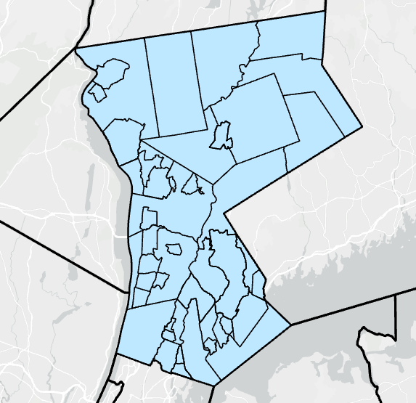

Using the Governors’ 2100 Commission report and the NYS Climate Impacts assessments, this document presents the Westchester County primary climate hazards and the risks and opportunities they present. A lot can change in a century, so it is never too early to start.

Climate Hazards in New York State
Three significant climate hazards (trends) are expected to affect New York State residents during the 21st century: increasing temperatures, rising sea level, and changing precipitation patterns. These trends are leading to three primary climate risks (human impacts): flooding, heat waves, and drought. Communities can plan and implement resilience strategies to reduce their vulnerability and thrive under changing conditions. Risks and resilience opportunities are discussed later in this document.
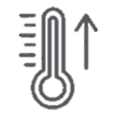Increasing Temperatures

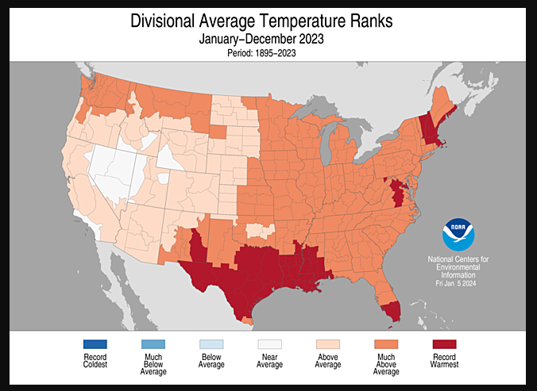
Annual average temperatures have been steadily increasing in New York State, posing new challenges to human health, electricity demand, and many of our industries, including tourism, recreation, and agriculture. Since 1970, temperature increases in New York have surpassed national and global averages:
- 2023 Global annual average temperature up 2.12°F above 20th century average¹
- 2023 U.S. annual average temperature up 2.4°F above 20th century average²
- 2023 New York annual average temperature up 2.2°F above the average from 1991-2020²

The average annual temperature around Westchester County is expected to increase approximately four to six degrees by mid-century and as much as 11 degrees by 2100.² As a reference point, by the 2080s, New York City’s average temperature is projected to be on par with the 20th century average for Birmingham, Alabama.³
 | Baseline  1981 -2010 | 2030s | 2050s | 2080s | 2100
Annual average air temperature | 50.8° F | 52.8 – 55.7°F | 54 – 58°F | 55.6 – 62.7°F | 56° – 64.7°F
Increase in annual average |  | 2.0 – 4.9°F | 3.2 – 7.2°F | 4.8 – 11.9 | 5.2 – 13.9°F

Table 1. Like all projections, these climate projections have uncertainty embedded within them. Sources of uncertainty include data and modeling constraints, the random nature of some parts of the climate system, and limited understanding of some physical processes. Levels of uncertainty are characterized using state-of-the-art climate models, multiple scenarios of future greenhouse gas concentrations, and recent peer-reviewed literature. Even so, the projections are not true probabilities, so the specific numbers should not be emphasized, and the potential for error should be acknowledged. Source: Climate Impacts Assessment³

Rising Sea Level 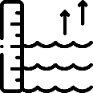
Global sea level is rising due to various factors, including thermal expansion from warmer water temperatures, and melting of land-based ice. The Hudson River is connected to and influenced by the sea; therefore, it experiences tides and contains saltwater in its lower reaches. This is why the river south of the federal dam at Troy is considered an estuary. It is also the reason why the Hudson River’s water level is rising with global sea level.

Since 1900, sea level in the lower Hudson Valley has risen over 13 inches.⁴ Below are Albany sea level rise projections taken from the 2023 Climate Impacts Assessment for New York State which are based on the results from the IPCC 6th Assessment report and show the range from the low-estimate (10th percentiles) to the high-estimate (90th percentiles). The table showing the projections of the Sea-level rise with rapid ice melt were taken from NYS 2100 Commission Report. The rapid-ice melt scenario is based on acceleration of recent rates of ice melt in the Greenland and West Antarctic Ice sheets and paleoclimate studies. These projections are consistent with the most recent projections released by New York State in the Governor's 2100 Commission report (http://goo.gl/K9ohoi).⁵

 | Baseline  1981 -2010 | 2030s | 2050s | 2080s | 2100
New York City  (The Battery)  Sea Level Rise - Inches | - | 6” – 13” | 12” – 23” | 21” – 45” | 25” – 65”

Table 2. Like all projections, these climate projections have uncertainty embedded within them. Sources of uncertainty include data and modeling constraints, the random nature of some parts of the climate system, and limited understanding of some physical processes. Levels of uncertainty are characterized using state-of-the-art climate models, multiple scenarios of future greenhouse gas concentrations, and recent peer-reviewed literature. Even so, the projections are not true probabilities, so the specific numbers should not be emphasized, and the potential for error should be acknowledged. Source: NYS Climate Impacts Assessments.³
 |  | 2020s | 2050s | 2080s | 2100
Sea- Level Rise with Rapid Ice Melt | No baseline | 4”- 9” | 17”-26” | 37”-50” | 52” – 68”

Table 3. Values are the central range (middle 67%) of model-based probabilities. Values are the central range (middle 67%) of model-based probabilities rounded to the nearest inch. The rapid-ice melt scenario is based on acceleration of recent rates of ice melt in the Greenland and West Antarctic Ice sheets and paleoclimate studies. These projections are consistent with the most recent projections released by New York State in the Governor's 2100 Commission report. Source: NYS 2100 Commission Report.⁵
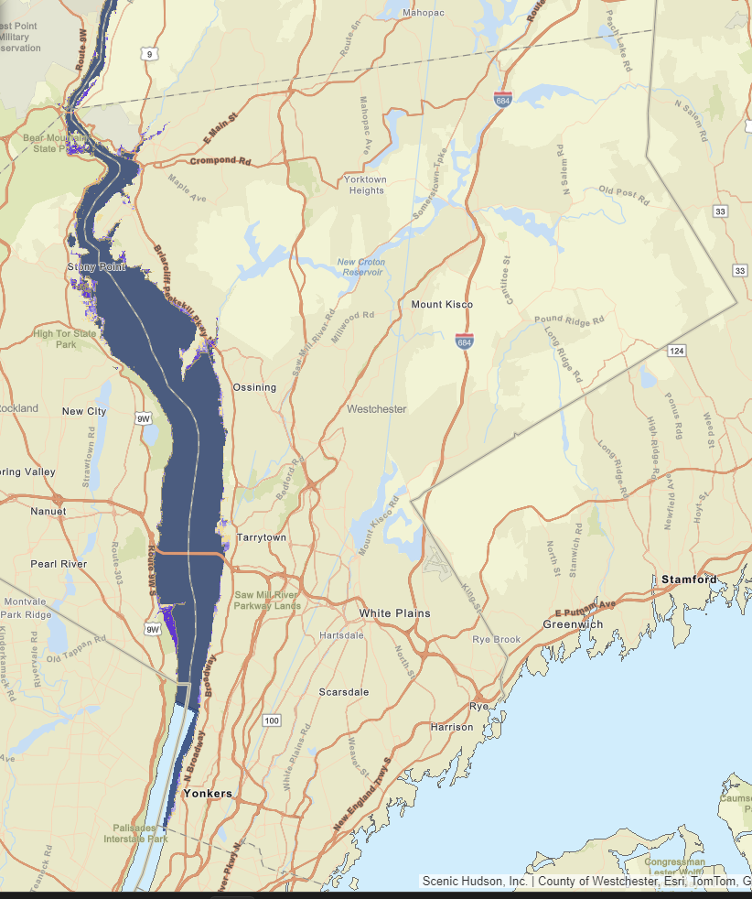

Figure 3. Map of Sea level rise projections for Westchester County shown for six feet of sea level rise. Source: Scenic Hudson’s Sea Level Rise Mapper. ⁶

Changing precipitation patterns

Precipitation has become more variable and extreme, whereas total rainfall has changed only marginally. The total annual precipitation in New York State from 1901 – 2022 has increased by 10% to 20%. Overall, while New York is projected to remain a “water-rich” state, water quality can be affected by increased in total precipitation.³

Below you will find a table depicting the projections for the average precipitation (mean precipitation) for the South Hudson River Valley in Westchester County. These projections were taken from the NYS Climate Impacts Assessment and are based on the global climate model (GCM) simulations from the latest version of the world climate research program’s Coupled Model Intercomparison project ³

 | Baseline  1981-2010 | 2030s | 2050s | 2080s | 2100
Mean Precipitation | 45.8 ’ | 45.8” – 50.4” | 46.3” – 51.8” | 46.7” – 55.9” | 44.9” – 58.6”
% Increase in precipitation |  | 0 – 10% | 1 – 13% | 2 – 22% | 2 – 28%

Table 4. Like all projections, these climate projections have uncertainty embedded within them. Sources of uncertainty include data and modeling constraints, the random nature of some parts of the climate system, and limited understanding of some physical processes. Levels of uncertainty are characterized using state-of-the-art climate models, multiple scenarios of future greenhouse gas concentrations, and recent peer-reviewed literature. Even so, the projections are not true probabilities, so the specific numbers should not be emphasized, and the potential for error should be acknowledged. Source: NYS Climate Impacts Assessments.³

Climate Risks and Opportunities for Westchester County
An analysis of historical trends in annual average temperature and precipitation was conducted for 27 weather stations across New York State. Below are the results from the Southern Hudson River Valley’s Dobbs Ferry weather station in New York State taken from the latest New York State Climate Change Projections.³
Annual Average Temperature form 1901– 2020 from observed weather stations
- Temperature increase for Southern Hudson River Valley – Dobbs Ferry: 0.34 °F/decade
Trends in Annual Precipitation from 1901–2020 for Observed Weather Stations in New York State
- Precipitation increase for Southern Hudson River Valley – Dobbs Ferry: 0.39 inches/decade
Table 5. Trend is significant at the 99% significance level. Source: Weather Station Data: Dobbs Ferry, NY
Projected Changes in Extreme Events for Dobbs Ferry, New York
 | Baseline  1981-2010 | 2030s | 2050s | 2080s
# Days per year above 90°F | 18 | 29 – 57 | 34 – 73 | 48 – 108
# Days per year above 95°F | 4 | 7 – 29 | 9 – 38 | 18 – 76
# Heat waves per year | 2 | 4 – 8 | 5 – 9 | 6 – 10
Average # days of each heat wave | 4 | 5 – 6 | 5 – 6 | 5 – 10
Maximum heat Index | 100 | 106 – 114 | 108 – 120 | 112 – 136
# Days per year  ≤ 32°F | 106 | 67 – 90 | 37 – 82 | 8 – 74

 | Baseline  1981-2010 | 2030s | 2050s | 2080s
# Days with precipitation > 1” | 15 | 15 – 19 | 15 – 18 | 15 – 19
# Days with precipitation > 2” | 3 | 4 – 5 | 4 – 5 | 4 – 6
# Days with precipitation > 4” | 0.2 | 0.2 | 0.2 | 0.2 – 0.6

Table 6. Projections are based on 16 GCMs (14 for heat index) and 2 SSPs and are relative to the 1981– 2010 base period. Baseline data are for the 1981–2010 base period and are from the NOAA National Centers for Environmental Information (NCEI). Decimal places are shown for values less than 1, although this does not indicate higher precision or certainty. Heat index was computed using the formula from the National Weather Service. Source: Stevens, A., & Lamie, C., Eds. (2024). New York State Climate Impacts Assessment: Understanding and preparing for our changing climate. https://nysclimateimpacts.org

Summary of Findings: Key Assets and Vulnerabilities

Process and Stakeholder Engagement

Example:

The CAPI-Town CAPI Adapt team undertook stakeholder engagement work of identifying climate-vulnerable assets in five phases.

- Phase 1: Planning Workshop. The core CAPI-Town CAPI team participated in a CAPI Adapt program workshop on February 8, 2024. In that workshop, the Team engaged in three exercises on equity brainstorming, assessing community assets and vulnerabilities, and adaptation ranking strategies. The Team was asked to identify infrastructural, environmental, and social assets in the community, determine which assets are most susceptible to the identified climate hazards, and to prioritize potential actions to safeguard these assets. The CAPI Adapt workshop yielded a number of assets, which were then organized into distinct categories or areas of concern and prioritized. The output of this work was shared with the Climate Smart Communities Task Force.
- Phase 2: Municipal Stakeholder Input. Following that, on [DATE] an in-person meeting was held with the [Supervisor/Mayor] and members of the [police, fire department, and municipal staff responsible for emergency management services]. They were shown the initial findings and also asked to identify infrastructural, environmental, and social assets in the community, determine which assets are most susceptible to the identified climate hazards, and to prioritize potential actions to safeguard these assets.
- Phase 3: Community-wide Stakeholder Outreach. In [DATE], a Climate Vulnerability Assessment survey was made available online to all residents of CAPI-Town as well as all municipal staff. It took approximately 10 minutes to complete. The survey announcement was available on the municipal web site and a link was emailed to all residents. Residents had 4 weeks to complete the survey. Over 10% responded to the survey.
- Phase 4: Focused Resident Outreach and Engagement. Lastly, the Team met with the Youth Council on [DATE], the Senior Council to seek out input from more vulnerable residents, and also tabled at the April and May Farmer’s Markets where they distributed fact sheets on the CAPI program and flyers on preliminary findings. The fact sheet and the flyer both provided a QR code to allow residents to participate. The Team met with the Climate Advisory Council and the Climate Smart Communities Task Force to gather further input and feedback on [DATE].
- Phase 5: Municipal Council. Finally, CAPI-Town CAPI Adapt team members presented a draft CVA to the CAPI-Town for review on [DATE]. In each phase, The CAPI-Town CAPI Adapt Team provided project updates on the municipal web site.

Key Assets

In this section, you should highlight community systems and assets of concern from your vulnerability assessment. You should use the Exposure Matrix Activity you started during the CAPI Adapt Workshop, as well as follow-up stakeholder feedback and input, to help inform your write-up.

Assets are broken into 3 categories:
- Infrastructure Assets
  - Transportation
  - Systems Infrastructure
  - Municipal Structures
  - Other Structures
- Environmental Assets
  - Environmental or Natural Assets
  - Public Parks and Recreation Areas
- Social Assets
  - Emergency Services
  - Vulnerable Communities and Food Security

In each of the 3 sections, provide more detail on assets such as emergency services, vulnerable communities, and/or food security. Explain what rose as a top priority during the workshop, the survey and/or during stakeholder engagement. As a reminder, the community system assets and categories considered were the following:

- Homes, businesses, and public buildings
- Transportation systems
- Parks and natural areas
- Water and wastewater infrastructure
- Energy infrastructure
- Public health and healthcare
- Food supply/distribution
- Communications infrastructure
- Community and cultural spaces
- Educational institutions
- Emergency response
- Farms and agriculture
- Local economy and jobs

You can also refer to the NY State Template for Local Climate Change Adaptation Plan, p. 39-41 as an example.
Infrastructure Assets

Systems Infrastructure

Example:

Both the Emergency Team and the community expressed concerns about the vulnerability of the CAPI-Town power grid. Physical components of the electric grid, such as above-ground power lines, are sensitive to extreme weather events, while increased demand for air conditioning during heat spells can overwhelm its delivery capacity. A resident recounted this statement during the last big storm, “ZZ”.

Investment and maintenance from Con Edison are crucial for the adaptive capacity of the system's physical components, particularly utility poles, and overhead power lines. However, the implementation of backup power generation offers a more cost-effective and easily deployable solution, enhancing the system's adaptability to climate changes. The need for backup generators or battery storage at municipal buildings was mentioned, along with the scarcity of gas stations equipped with backup power.

The CAPI-Town wastewater and sewer infrastructure was also raised as a concern, with numerous culverts identified by the Emergency Team as needing maintenance, repair, or replacement. Particularly sensitive to severe storms and heavy precipitation, the wastewater system struggled due to undersized or clogged storm drains, leading to residential flooding and erosion. Certain low-lying areas are prone to flooding due to frequently clogged storm drains, converging storm basins, and/or limited drainage capacity. Residents mentioned blocked storm drains, exacerbated by road repairs, and natural factors like a nearby spring as vulnerabilities.

Environnemental Assets

Environnemental or Natural Assets

Example:

Some consider the CAPI-Town environmental assets vulnerabilities while others saw them as strengths in the face of our primary climate hazards. These assets, including open spaces, natural resources, and floodwater storage, offer essential ecosystem services but are also susceptible to flooding and damage from storm surge. The CAPI-Town forests, in particular, were identified as highly vulnerable due to their sensitivity to changing precipitation patterns, increasing temperatures, and rising sea levels.

The emergency management team agreed that the threat of flooding and extreme precipitation threatens the structural integrity of the CAPI-Town aging infrastructure. To address these challenges and enhance adaptive capacity, the CAPI-Town is working on forest restoration efforts.

Similarly, the CAPI-Town Hudson River shoreline is vulnerable to storm surges and rising sea levels. Efforts are underway to safeguard this area, beginning with a study on the effects of erosion and the implementation of measures to protect the ecosystem.

Social Assets

Food Security and Vulnerable Populations

During the kick-off workshop, concerns were raised about the availability of water and food, with a particular focus on the Food Pantry and the Farmer’s Market, to power outages from severe storms and extreme heat events. In the Survey, while most residents reported generally accessible healthy and affordable food, XX% expressed uncertainty about the resilience of our food supply to extreme climate events. One resident stated, “YY”.

The municipal water supply system was also flagged as potentially susceptible to climate change. The emergency management team noted aging underground pipes, some of which require replacement. A resident emphasized the need for proactive measures to reduce water consumption and implement best practices, stressing the importance of strategic planning for worst-case water shortage scenarios. Another resident echoed concerns about the integrity and upkeep of the infrastructure, citing past issues with communication and response to local leaks.

In terms of vulnerable populations, residents identified the elderly and those reliant on the food pantry to supplement their food intake as particularly threatened by climate changes.

Conclusion
Briefly describe conclusions and your municipality’s next steps. You may want to discuss municipal public meetings held and/or the results of the community survey, if you did one.

Example:

This Climate Vulnerability Assessment integrates scientific data and the perspectives of residents and key stakeholders regarding climate hazards in our region. The Assessment outlines, analyzes, and prioritizes the impacts of priority climate hazards on key assets in the CAPI-Town. Throughout the assessment, diverse and thoughtful feedback was received at each stage of the process. The assessment reflects the dedication of municipal officials, staff, the City’s Council, commissions, and numerous residents to safeguarding identified unique and irreplaceable assets.

The Climate Vulnerability Assessment integrates scientific findings with the perspectives of residents and Town Staff regarding potential climate hazards and priority assets. Throughout the process, we received comprehensive and thoughtful feedback at each stage. The process of undertaking the Assessment showcased the dedication of municipal officials, staff, Town boards, commissions, and numerous residents to safeguarding the unique and irreplaceable assets identified in the CAPI-Town.

Acknowledging that perceptions and priorities evolve, the CAPI Adapt Team is dedicated to sustaining the dialogue and continuing climate vulnerability, adaptation, and resilience planning. The next steps involve creating a climate adaptation chapter for our Climate Action Plan. The authors are confident that this report will inform and contribute to future municipal plans and development projects, aiding the CAPI-Town in cost-effective and efficient climate adaptation efforts.

The CAPI-Town commits to reviewing this Assessment at least once every five years. A periodic review of the Assessment can help inform other municipal planning initiatives. Through ongoing dialogue, research, prioritization, reassessment, and planning, the authors envision this Climate Vulnerability Assessment as a living document and the cornerstone for a comprehensive Climate Action Plan and a key component of our resilient vision guiding the CAPI-Town’s long-term sustainability efforts.

Appendix A: References

1 NOAA National Centers for Environmental Information, Monthly Global Climate Report for Annual 2023, published online January 2024, retrieved on February 7, 2024 from https://www.ncei.noaa.gov/access/monitoring/monthly-report/global/202313.
2 NOAA National Centers for Environmental Information, Monthly National Climate Report for Annual 2023, published online January 2024, retrieved on Jan 31, 2024 from https://www.ncei.noaa.gov/access/monitoring/monthly-report/national/202313.
3 Stevens, A., & Lamie, C., Eds. (2024). New York State Climate Impacts Assessment: Understanding and preparing for our changing climate. https://nysclimateimpacts.org
4 Horton, R., D. Bader, C. Rosenzweig, A. DeGaetano, and W.Solecki. 2014. Climate Change in New York State: Updating the 2011 ClimAID Climate Risk Information. New York State Energy Research and Development Authority (NYSERDA), Albany, New York. https://www.nyserda.ny.gov/climaid
5 Recommendations to Improve the Strength and Resilience of the Empire State’s Infrastructure NYS 2100 COMMISSION https://www.cakex.org/sites/default/files/documents/NYS2100.pdf.
6 Hudson, Scenic. “Sea Level Rise Mapper .” Scenichudson.Maps.Arcgis.Com, Scenic Hudson, scenichudson.maps.arcgis.com/apps/MapJournal/index.html?appid=3a3d0dc3884c4637ad0a51f4aa912189. Accessed 31 Jan. 2024.

Appendix B: Key Terms
Key terms from the NY State Template for Local Climate Change Adaptation Plan, p. 13

Adaptation (climate change): Actions that reduce the level of physical, social, or economic impact of climate change and variability, or take advantage of new opportunities emerging from climate change (Rosenzweig et al., 2011). It includes reducing the vulnerability of people, places, and ecosystems to the impacts of climate change.
Adaptive capacity: The ability of systems, institutions, humans, and other organisms to adjust to potential damage, to take advantage of opportunities, or to respond to consequences (IPCC, 2014).
Climate change: A statistically significant variation in either the mean state of the climate, most often surface variables such as temperature, precipitation, and wind, or in its variability, persisting for an extended period (typically decades or longer) (Wuebbles et al., 2017).
Climate change effects: The physical effects of anthropogenic climate change, including changes in average temperatures, precipitation rates, sea level rise, and ocean temperatures.
Climate change impacts: The impacts experienced by a human, natural system, or man-made system as a result of climate variation including physical changes in average conditions or extreme weather. Examples of climate change impacts include flooding of homes or ecosystem changes (Vogel et al., 2016).
Drought: A period of unusually persistent dry weather that persists long enough to cause a water supply shortage (NOAA, 2015).
Ecosystem-based Adaptation (EbA): The use of biodiversity and ecosystem services as part of an overall adaptation strategy to help people to adapt to the adverse effects of climate change (IPCC, 2014).
Ecosystem services: Ecological processes or functions having monetary or non-monetary value to individuals or society at large. These are frequently classified as (1) supporting services such as productivity or biodiversity maintenance, (2) provisioning services such as food or fiber,
(3) regulating services such as climate regulation or carbon sequestration, and (4) cultural services such as tourism or spiritual and aesthetic appreciation (IPCC, 2014).
Exposure: The degree to which elements of a system are in direct contact with climate variables, may be affected by long-term changes in climate conditions or by changes in climate variability, including the frequency and magnitude of extreme weather (Rosenzweig et al., 2011).
Extreme heat: Individual days with a maximum temperature at or above 90°F or above 95°F; threshold used depends on the region within the state (Rosenzweig et al., 2011).
Extreme cold: Individual days with a maximum temperature at or below 32°F or below 0°F; threshold used depends on the region within the state (Rosenzweig et al., 2011).
Extreme precipitation: Event with more than 1, 2, or 4 inches of precipitation over a 24-hour period; threshold used depends on the region within the state (Rosenzweig et al., 2011).
Extreme weather: A period of abnormal weather conditions that can negatively affect humans, natural and man-made resources. Extreme weather is often used as an umbrella term referring to a combination of extreme heat, extreme cold, extreme precipitation, or extreme wind.

Extreme wind: Period with sustained or gusting wind speeds high enough to cause damage to trees, power lines, and other types of natural or man-made resources (NOAA, n.d.).
Flood or flooding: A temporary inundation of normally dry land area caused by an increase in water levels in nearby water bodies including lakes, rivers, estuaries, and oceans or by localized accumulation of precipitation (FEMA, 2017).
Greenhouse gas (GHG): Any gas that absorbs infrared radiation in the atmosphere; examples include carbon dioxide, methane, nitrous oxide, ozone, and water vapor.
Heat wave: Three consecutive days with maximum temperatures above 90°F (Rosenzweig et al., 2011).
Maladaptation: Adaptive actions that may lead to increased risk of adverse climate-related outcomes, increased vulnerability to climate change, or diminished welfare, now or in the future (IPCC 2014).
Mitigation (climate change): Actions that reduce the levels of greenhouse gases in the atmosphere; includes reducing emissions of greenhouse gases and enhancing sinks (things that absorb more greenhouse gases than they emit). Examples include switching to renewable energy sources and implementing energy efficiency measures.
Nature-based solutions (NbS): Actions to protect, sustainably manage, and restore natural or modified ecosystems that address societal challenges effectively and adaptively, simultaneously providing human well-being and biodiversity benefits (IUCN, 2016).
Resilience: The capacity of social, economic, and environmental systems to cope with a hazardous event or trend or disturbance, responding or reorganizing in ways that maintain their essential function, identity, and structure, while also maintaining the capacity for adaptation, learning, and transformation (IPCC, 2014).
Sensitivity: How much a system is directly or indirectly affected by changes in climate conditions (e.g., temperature and precipitation) or specific climate change impacts (e.g., sea level rise and increased water temperature). If a system is likely to be affected as a result of projected climate change, it should be considered sensitive to climate change.
Vulnerability: The degree to which systems are susceptible to, and unable to cope with, adverse impacts of climate change (Rosenzweig et al., 2011). Generally, systems that are sensitive to climate and less able to adapt to changes are considered to be vulnerable to climate change impacts.
Winter warming: The average temperature increase over December, January, and February (Rosenzweig et al., 2011).

