WORKING TOWARD CLIMATE RESILIENCE
General climate information prepared for
Dutchess County
January 2024

Introduction
DUTCHESS COUNTY
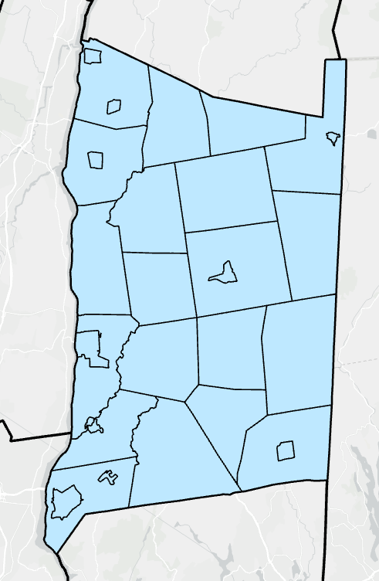
The Hudson River Estuary Program prepared this summary of climate planning as a part of the Climate Action Planning Institute (CAPI). It identifies historic climate trends and introduces future projections and strategies to address the climate hazards most likely to affect Dutchess County.
This summary provides a starting point for recognizing important climate hazards and risks in the county but is limited to information available to the New York State Department of Environmental Conservation (NYS DEC) and its partners at the time of this writing and is not a substitute for on-site survey and assessment. New York’s changing climate presents new challenges and opportunities for communities in the state. It is vital for local decision-makers and community members to understand their community’s vulnerability to a changing climate and take steps to increase their climate resilience.

Using the Governor’s 2100 Commission report and the NYS Climate Impacts assessments, this document presents the Dutchess County primary climate hazards and the risks and opportunities they present. A lot can change in a century, so it is never too early to start.
Figure 1. Map of Dutchess County

Table of Contents
Introduction 1
Climate Hazards in New York State 3
Increasing Temperatures 3
Rising Sea Level 4
Changing precipitation patterns 6
Climate Risks and Opportunities for Dutchess County 7
References 8
Appendix A: Alternative Graphics for Climate Summaries 9
Appendix B: Alternative Hazards 13
Invasive Species 13
Appendix C: Partial List of Municipality Accomplishments 15

Climate Hazards in New York State
Three significant climate hazards (trends) are expected to affect New York State residents during the 21st century: increasing temperatures, rising sea level, and changing precipitation patterns. These trends are leading to three primary climate risks (human impacts): flooding, heat waves and drought. Communities can plan and implement resilience strategies to reduce their vulnerability and thrive under changing conditions. Risks and resilience opportunities are discussed later in this document.
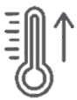

Increasing Temperatures
Figure 2. Average annual temperature as it compares to the average annual temperature for 1895-2023. Source: National Centers for Environmental Information.
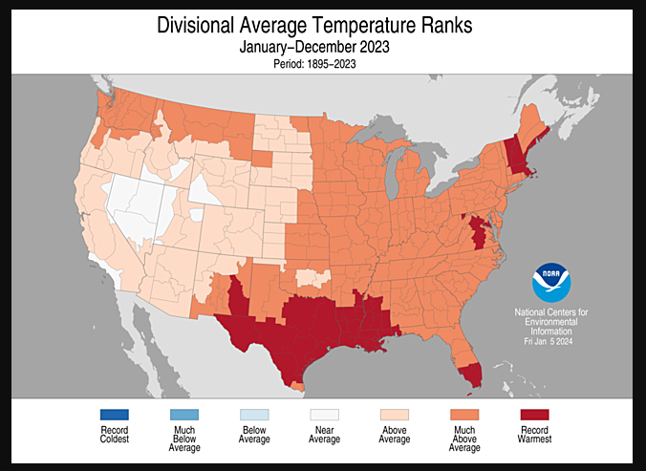

Annual average temperatures have been steadily increasing in New York State, posing new challenges to human health, electricity demand, and many of our industries, including tourism, recreation, and agriculture. Since 1970, temperature increases in New York have surpassed national and global averages with our winters being particularly hard hit:
- 2023 Global annual average temperature up 2.12°F above 20th century average¹
- 2023 U.S. annual average temperature up 2.4°F above 20th century average ²
- 2023 New York annual average temperature up 2.2°F above the average from 1991-2020²

The average annual temperature around Dutchess County is expected to increase approximately four to six degrees by mid- century and as much as 11 degrees by 2100.². As a reference point, by the 2080s, New York City’s average temperature is projected to be on par with the 20th century average for Birmingham, Alabama.³

Air Temperature Projections for the South Hudson River Valley
 | Baseline  1981 -2010 | 2030s | 2050s | 2080s | 2100
Annual average air temperature* | 50.8  ° F | 52.8 – 55.7°F | 54 – 58°F | 55.6 – 62.7°F | 56° – 64.7°F
Increase in annual average* |  | 2.0 – 4.9°F | 3.2 – 7.2°F | 4.8 – 11.9 | 5.2 – 13.9°F

Table 1. Like all projections, these climate projections have uncertainty embedded within them. Sources of uncertainty include data and modeling constraints, the random nature of some parts of the climate system, and limited understanding of some physical processes. Levels of uncertainty are characterized using state-of-the-art climate models, multiple scenarios of future greenhouse gas concentrations, and recent peer-reviewed literature. Even so, the projections are not true probabilities, so the specific numbers should not be emphasized, and the potential for error should be acknowledged. Source: Climate Impacts Assessment.³
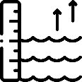

Rising Sea Level

Global sea level is rising due to various factors, including thermal expansion from warmer water temperatures, and melting of land-based ice. The Hudson River is connected to and influenced by the sea; therefore, it experiences tides and contains saltwater in its lower reaches. This is why the river south of the federal dam at Troy is considered an estuary. It is also the reason why the Hudson River’s water level is rising with global sea level.

Since 1900, sea level in the lower Hudson has risen over 13 inches.⁴ Below are Albany sea level rise projections taken from the 2023 Climate Impacts Assessment for New York State which are based on the results from the IPCC 6th Assessment report and show the range from the low-estimate (10th percentiles) to the high-estimate(90th percentile).³ The table showing the projections of the Sea-level rise with rapid ice melt were taken from NYS 2100 Commission Report. The rapid-ice melt scenario is based on acceleration of recent rates of ice melt in the Greenland and West Antarctic Ice sheets and paleoclimate studies. These projections are consistent with the most recent projections released by New York State in the Governor's 2100 Commission report (http://goo.gl/K9ohoi).⁵

Sea Level Rise Projections
 | Baseline  1981 -2014 | 2030s | 2050s | 2080s | 2100
Albany Sea Level Rise - Inches | - | 5” – 12” | 11” – 21” | 18” – 41” | 21” – 60”

Table 2. Like all projections, these climate projections have uncertainty embedded within them. Sources of uncertainty include data and modeling constraints, the random nature of some parts of the climate system, and limited understanding of some physical processes. Levels of uncertainty are characterized using state-of-the-art climate models, multiple scenarios of future greenhouse gas concentrations, and recent peer-reviewed literature. Even so, the projections are not true probabilities, so the specific numbers should not be emphasized, and the potential for error should be acknowledged. Source: NYS Climate Impacts Assessments.³

 | 2020s | 2050s | 2080s | 2100
Sea- Level Rise with Rapid Ice Melt | 4”-9” | 17”-26” | 37”-50” | 52” – 68”

Table 3. Values are the central range (middle 67%) of model-based probabilities. Values are the central range (middle 67%) of model-based probabilities rounded to the nearest inch. The rapid-ice melt scenario is based on acceleration of recent rates of ice melt in the Greenland and West Antarctic Ice sheets and paleoclimate studies. These projections are consistent with the most recent projections released by New York State in the Governor's 2100 Commission report. Source: NYS 2100 Commission Report.⁵
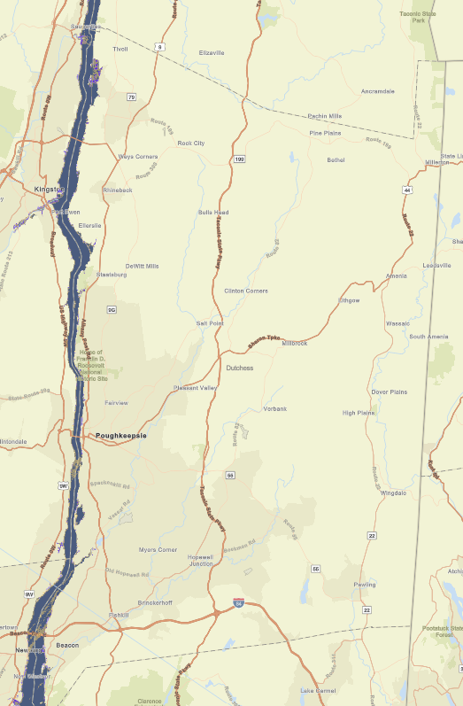

Figure 3. Map of Sea level rise projections for Dutchess County shown for six feet of sea level rise. Source: Scenic Hudson’s Sea Level Rise Mapper. ⁶


Changing precipitation patterns

Precipitation has become more variable and extreme, whereas total rainfall has changed only marginally. The total annual precipitation in New York State from 1901 – 2022 has increased by 10% to 20%. Overall, while New York is projected to remain a “water-rich” state, water quality can be affected by increased in total precipitation.³
Below you will find a table depicting the projections for the average precipitation (mean precipitation) for the South Hudson River Valley, of which Dutchess County is located in. These projections were taken from the NYS Climate Impacts Assessment and are based on the global climate model(GCM) simulations from the latest version of the World Climate Research Programme’s Coupled Model Intercomparison project ³

Precipitation Projections for the South Hudson River Valley

 | Baseline  1981 -2010 | 2030s | 2050s | 2080s | 2100
Mean Precipitation | 45.8 in. | 45.8” – 50.4” | 46.3” – 51.8” | 46.7” – 55.9” | 44.9” – 58.6”
% Increase in precipitation |  | 0 – 10% | 1-13% | 2 – 22% | -2 – 28%

Table 4. Like all projections, these climate projections have uncertainty embedded within them. Sources of uncertainty include data and modeling constraints, the random nature of some parts of the climate system, and limited understanding of some physical processes. Levels of uncertainty are characterized using state-of-the-art climate models, multiple scenarios of future greenhouse gas concentrations, and recent peer-reviewed literature. Even so, the projections are not true probabilities, so the specific numbers should not be emphasized, and the potential for error should be acknowledged. Source: NYS Climate Impacts Assessments.³

Climate Risks and Opportunities for Dutchess County

An analysis of historical trends in annual average temperature and precipitation were conducted for 27 weather stations across New York State. Below are the results from the Southern Hudson River Valley’s Poughkeepsie weather station in New York State taken from the latest New York State Climate Change Projections.³

Annual Average Temperature form 1901-2020 from observed weather stations
- Temperature increase for Southern Hudson River Valley - Poughkeepsie: 0.42 °F/decade
Trends in Annual Precipitation from 1901–2020 for Observed Weather Stations in New York State
- Precipitation increase for Southern Hudson River Valley – Poughkeepsie: 0.32 inches/decade

Table 5. Trend is significant at the 99% significance level. Source: Weather Station Data: Poughkeepsie, NY

Project Changes in Extreme Events for Region 5
The following projections are taken from the Responding to Climate Change in New York State ClimAID Report written in 2011 and updated in 2014. The report delineates climate projections by region. Region 5 (east of the Hudson River and the Mohawk River region), covers Albany, Columbia, Dutchess, Fulton, Herkimer, Madison, Montgomery, Oneida, Putnam, Rensselaer, Saratoga, Schenectady, Washington, and Westchester counties.⁴

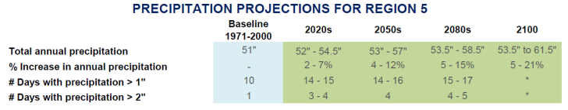

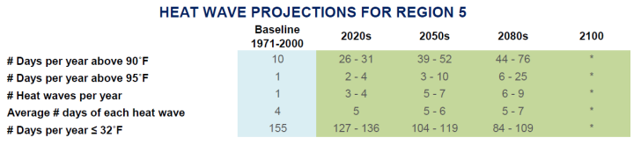

References

1 NOAA National Centers for Environmental Information, Monthly Global Climate Report for Annual 2023, published online January 2024, retrieved on February 7, 2024 from https://www.ncei.noaa.gov/access/monitoring/monthly-report/global/202313.
2 NOAA National Centers for Environmental Information, Monthly National Climate Report for Annual 2023, published online January 2024, retrieved on Jan 31, 2024 from https://www.ncei.noaa.gov/access/monitoring/monthly-report/national/202313.
3 Stevens, A., & Lamie, C., Eds. (2024). New York State Climate Impacts Assessment: Understanding and preparing for our changing climate. https://nysclimateimpacts.org
4 Horton, R., D. Bader, C. Rosenzweig, A. DeGaetano, and W.Solecki. 2014. Climate Change in New York State: Updating the 2011 ClimAID Climate Risk Information. New York State Energy Research and Development Authority (NYSERDA), Albany, New York. https://www.nyserda.ny.gov/climaid
5 Recommendations to Improve the Strength and Resilience of the Empire State’s Infrastructure NYS 2100 COMMISSION https://www.cakex.org/sites/default/files/documents/NYS2100.pdf.
6 Hudson, Scenic. “Sea Level Rise Mapper .” Scenichudson.Maps.Arcgis.Com, Scenic Hudson, scenichudson.maps.arcgis.com/apps/MapJournal/index.html?appid=3a3d0dc3884c4637ad0a51f4aa912189. Accessed 31 Jan. 2024.

Appendix A: Alternative Graphics for Climate Summaries

Graphics from Climate Impacts Assessment, 2023.
Stevens, A., & Lamie, C., Eds. (2024). New York State Climate Impacts Assessment: Understanding and preparing for our changing climate. https://nysclimateimpacts.org This work is licensed under CC BY 4.0

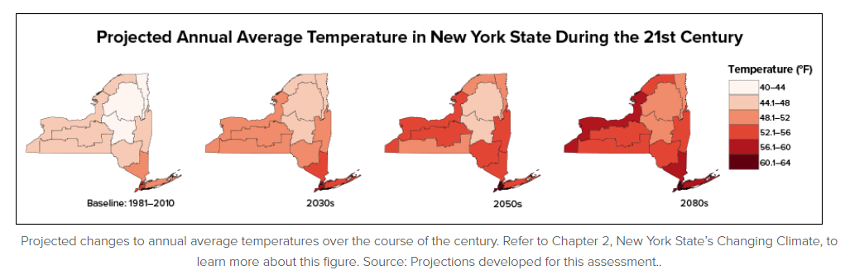

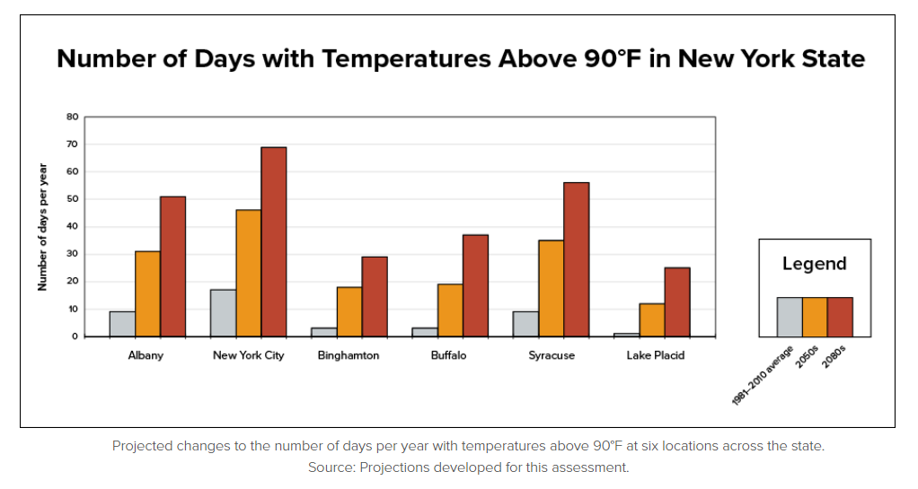
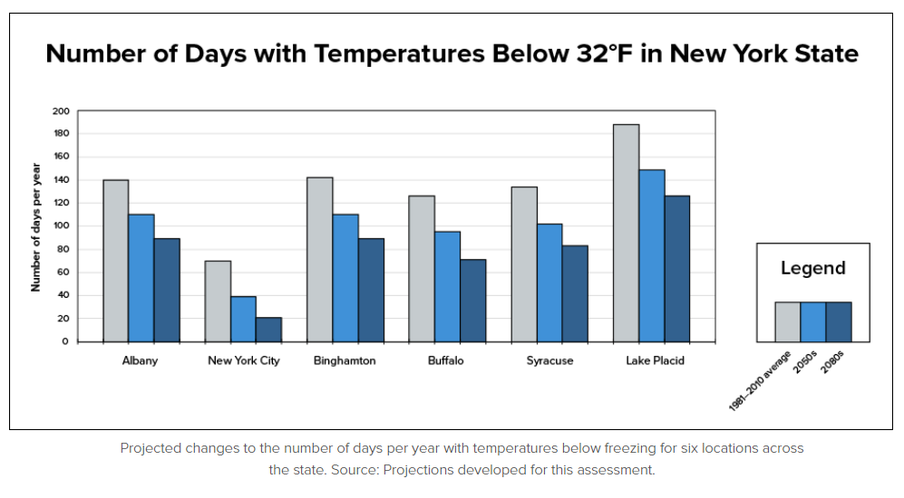

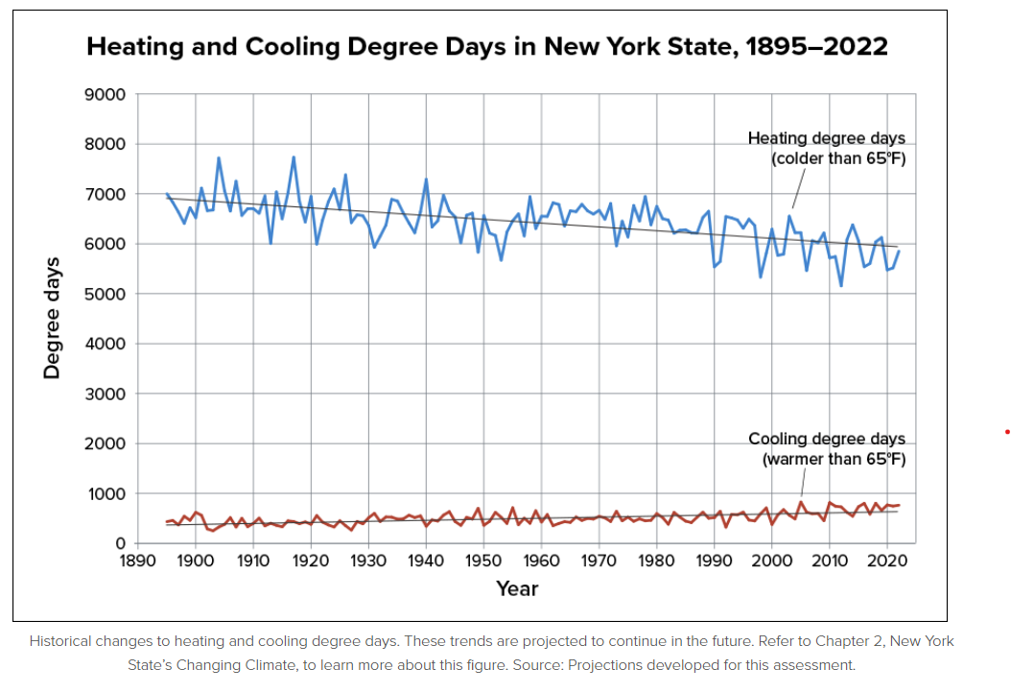
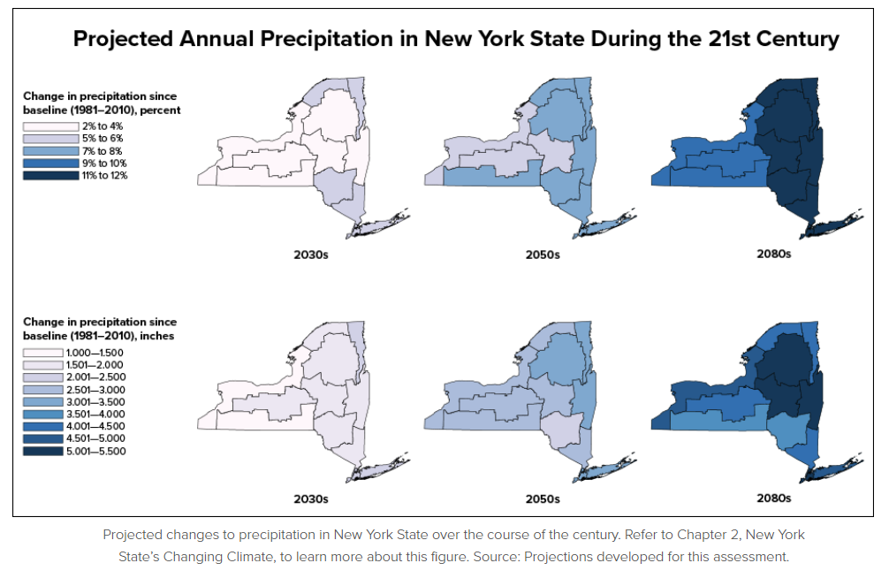

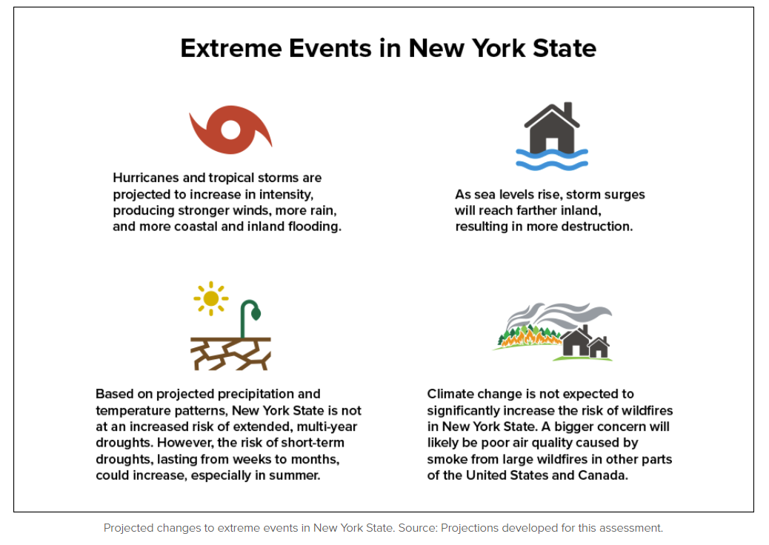
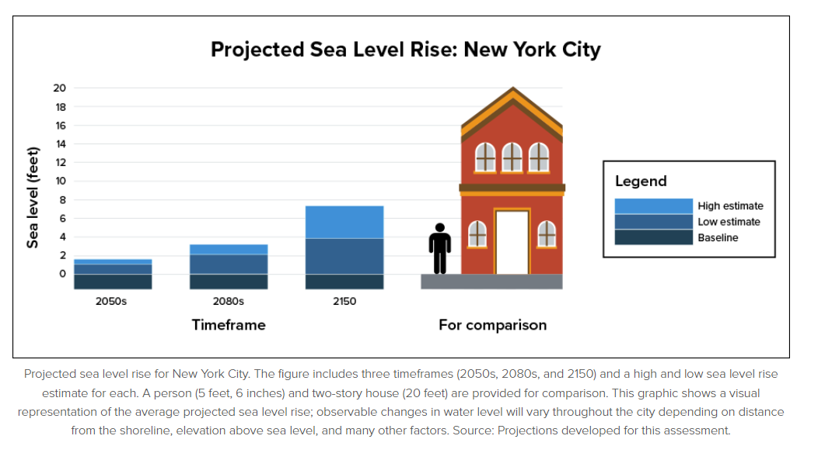

Appendix B: Alternative Hazards

Invasive Species

Invasive Species (Screenshots taken from CCE Dutchess Website )
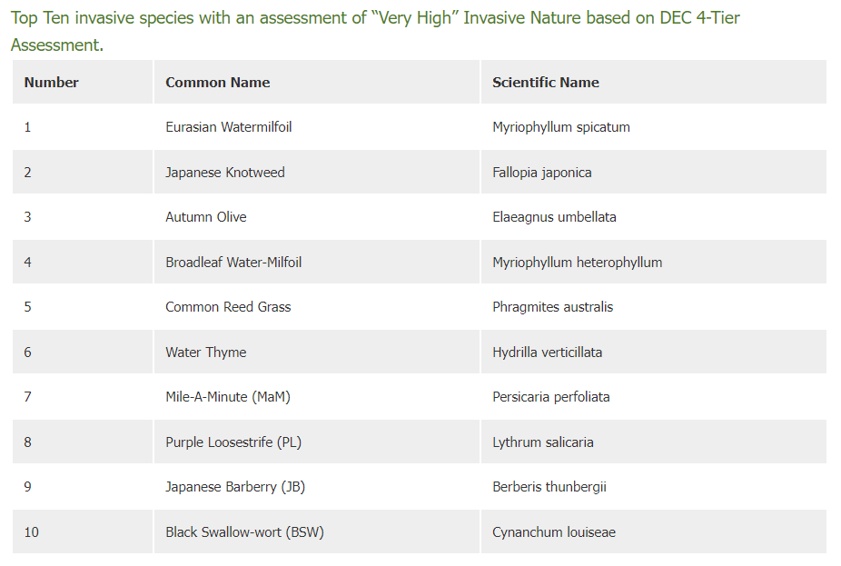

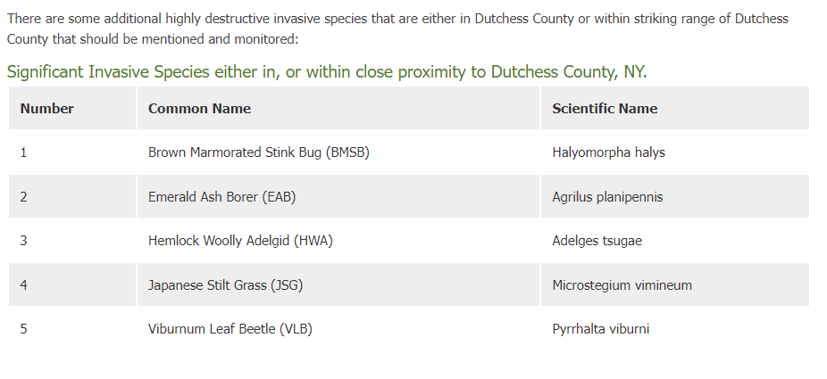
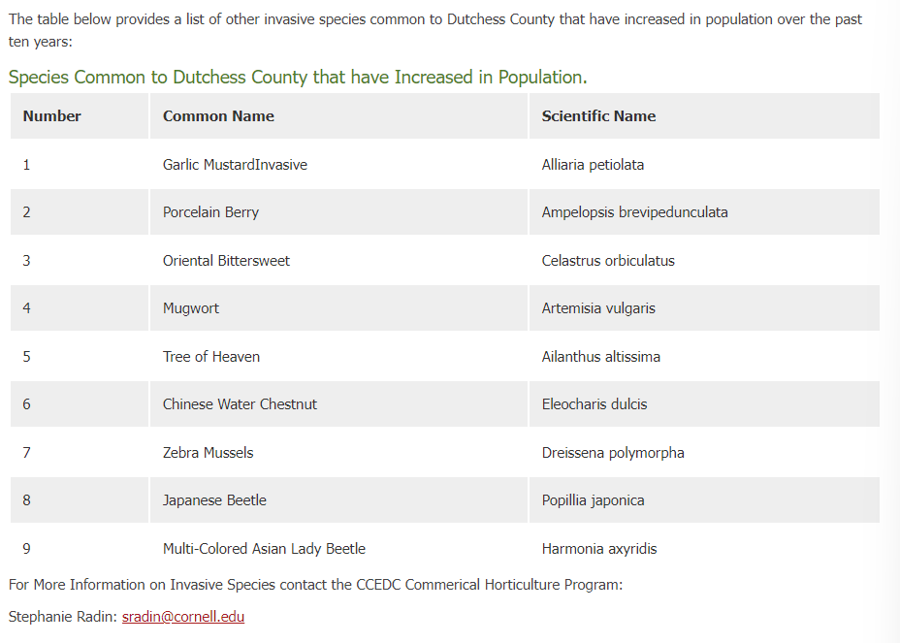

Appendix C: Partial List of Municipality Accomplishments

The below table is a partial accounting of related work and accomplishments from the Dutchess CAPI Adapt cohort. Some information may be outdated. It is included to encourage ideas and networking on potential recommended actions and strategies. For any questions, please contact <jesenia.laureano@dec.ny.gov >.
MUNICIPALITY | Pleasant Valley (Town) | Poughkeepsie (Town) | Rhinebeck (Town) | Rhinebeck (Village) | Wappingers Falls (Village) | Dutchess County
Registered Climate Smart Community
Certified Climate Smart Community
Completed Climate adaptive Design Studio Phase I
Completed Climate adaptive Design Studio Phase II
Flood Resilience Network Member
Climate Smart Community Actions Completed:
Pledge Element 6: Implement Climate-smart land-use
PE6:
Comp Plan with Sustainability Elements
PE6: Natural Resources Inventory
PE6: Zoning for Protection of Natural Areas (CLU)
Climate Smart Community Actions Completed:
Pledge Element 7: Enhance community resilience to climate change
PE7: Source Water Protection
PE7: Water Conservation & Reuse
PE7: Water-smart landscaping
PE7 Action: Climate Vulnerability Assessment
PE7: Evaluate Policies for Climate Resilience
PE7: Climate Adaptation Planning
PE7: Hazard Mitigation Plan
PE7: Heat Emergency Plan
MUNICIPALITY | Pleasant Valley (Town) | Poughkeepsie (Town) | Rhinebeck (Town) | Rhinebeck (Village) | Wappingers Falls (Village) | Dutchess County
PE7: Shade Structures Policy
PE7: Cooling Centers
PE7: Conserve Natural Areas
PE7: Watershed-based Flood Mitigation Plan
PE7: Design Flood Elevation & Flood Maps
PE7: Culverts and Dams
PE7: Freeboard Policies
PE7: Green Infrastructure
PE7: Riparian Buffers
PE7: Strategic Relocation
PE7: Nature-based Shorelines
PE7: National Flood Insurance Program Community Rating System
PE7: Watershed Plan for Water Quality
Climate Smart Community Actions Completed:
Pledge Element 9: Inform and inspire the public
PE9: Climate Change Education & Engagement

